**Hands-on No.: 7**

**Topic : Aggregation, Indexing, and Joining operations**

**Date : 23-09-2025**

**Aggregation:**

1. **Find the total number of doctors in each hospital.**

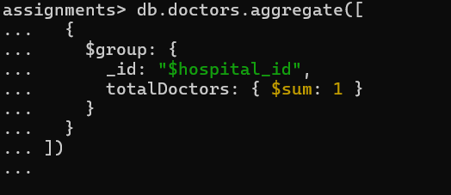

**2. List all patients along with their latest diagnosis (most recent health**

**record).**

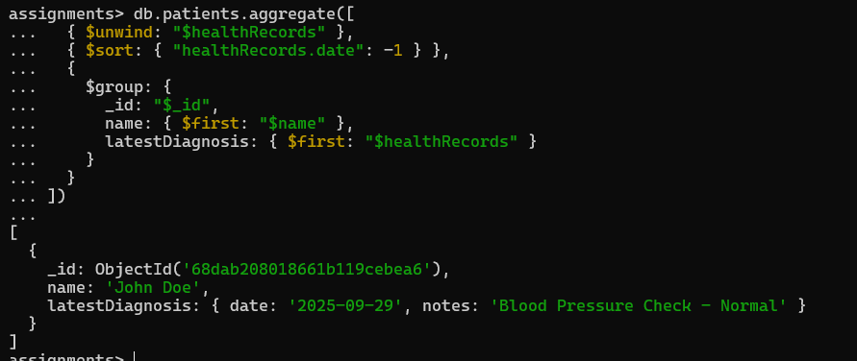

1. **Find the average age of all patients.**

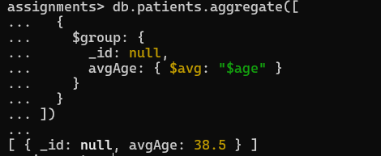

**4. For each doctor, find the total number of patients they have seen (based**

**on the appointments collection).**

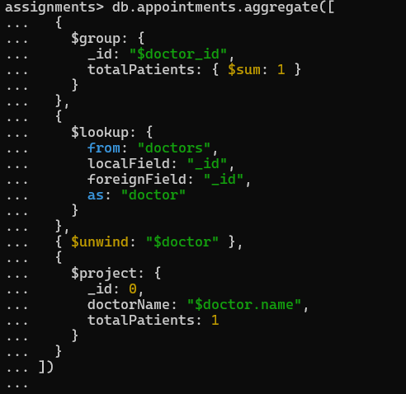

**5. List each hospital along with the average age of its patients (via linked**

**doctors and appointments).**

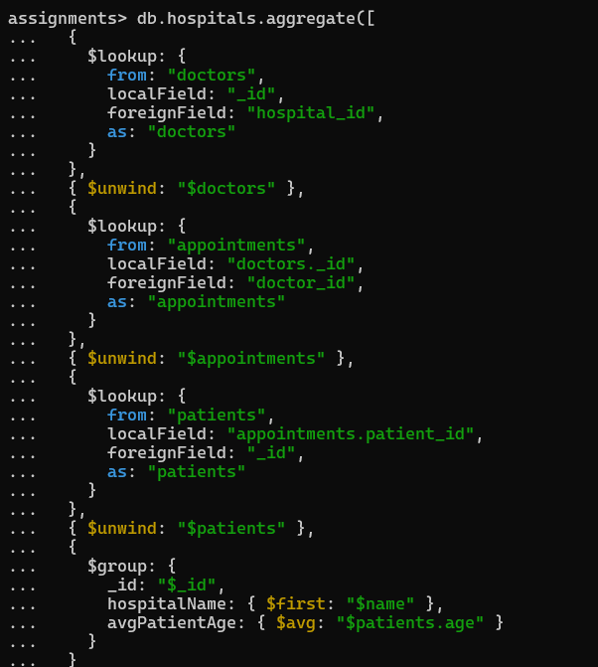

**6. Show all doctors and list the days they are available based on their**

**schedule field.**

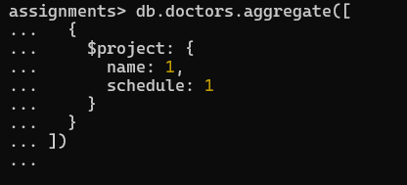

**Indexing:**

**1. Create an index on the doctors collection for the specialization field to**

**speed up queries.**



**2. Create a compound index on appointments for the doctorId and**

**appointmentDate fields to improve performance for finding a doctor’s**

**appointments by date.**



**3. Create an index on patients collection for the name and gender fields to**

**speed up queries filtering by name and gender.**



**4. Create an index on the admins collection’s role field to quickly find admins**

**by role.**



**5. Create an index on the appointments collection’s status field to efficiently**

**find appointments by status (Scheduled, Completed, Cancelled).**



**Joining:**

1. **List all appointments along with patient and doctor names.**

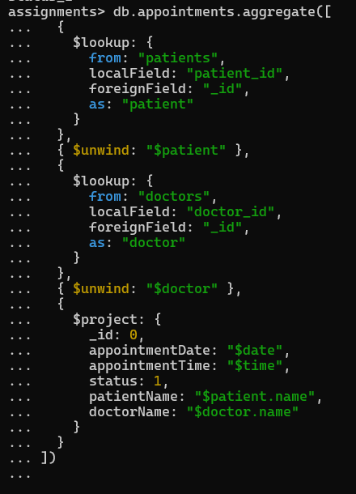

1. **List all doctors along with the name of the hospital they work in.**

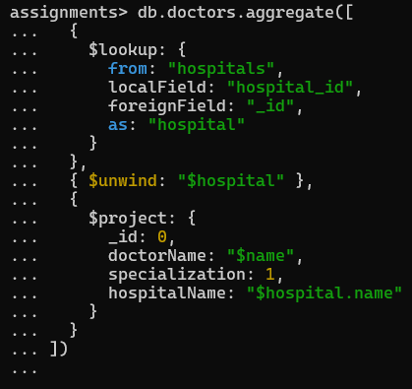

1. **List patients and their assigned doctor’s name.**

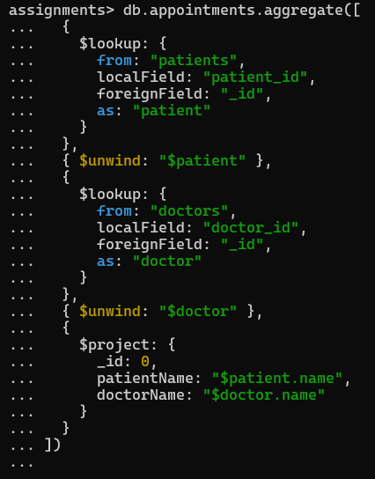

**4. For each hospital, list the number of appointments scheduled with its**

**Doctors**

